Kyle

Schematic Comments
No comments. Looks good.

Layout Comments
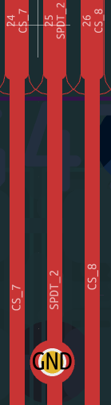
Shorted SPDT_2 to GND

